Category 1 Questions: SIMPLE QUERIES

- Select total count of patients from the demography table.
QUERY:
OUTPUT:
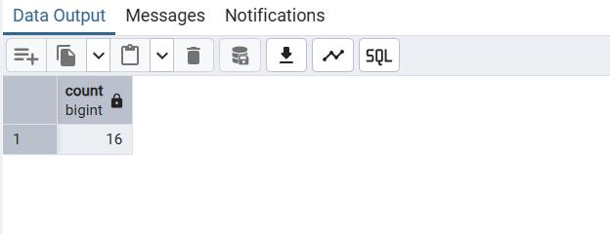

- Select total count of male/female from the demography table.
QUERY:


OUTPUT:
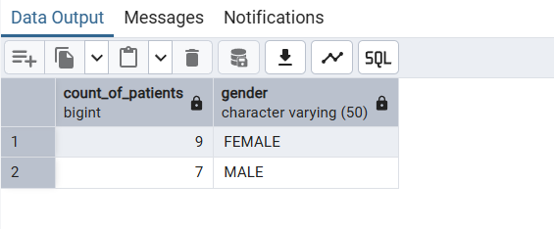

- What percentage of dataset is maleVsfemale?

QUERY:

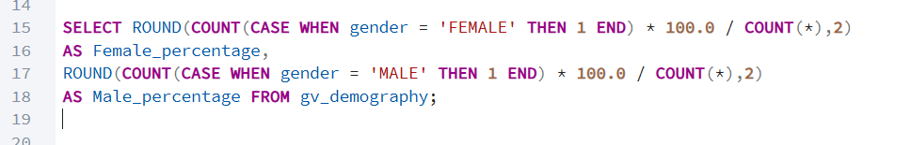
OUTPUT:
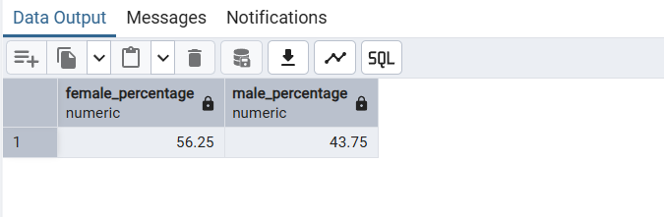

- Which patient have the maximum hba1c?

QUERY:



OUTPUT:
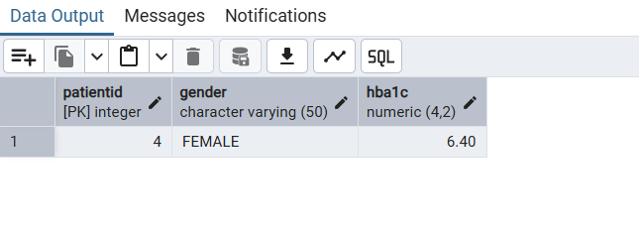
- Find the Average glucose level of patients day wise with their gender?
QUERY:


OUTPUT:
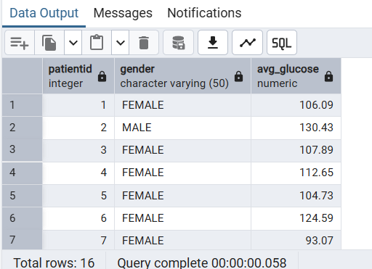

- Group patients by the glucose range as ‘normal’, ‘prediabetic’ or ‘diabetic’
QUERY:

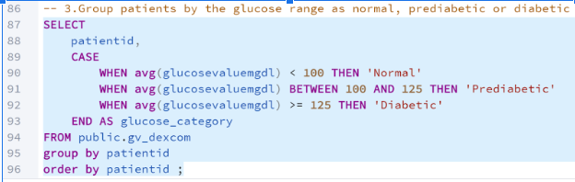
OUTPUT:

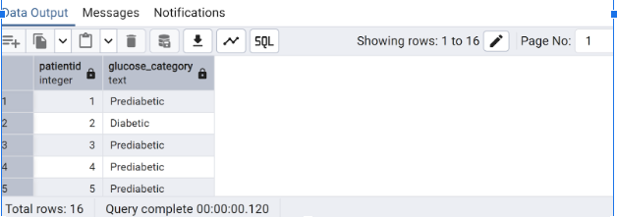

Insights: By categorizing patients based on glucose values,we understand risk distribution and could guide 'PreDiabetics' to prevent progression to Diabetes.

- Patients count by category (‘normal’, ‘prediabetic’ or ‘diabetic’)
QUERY:
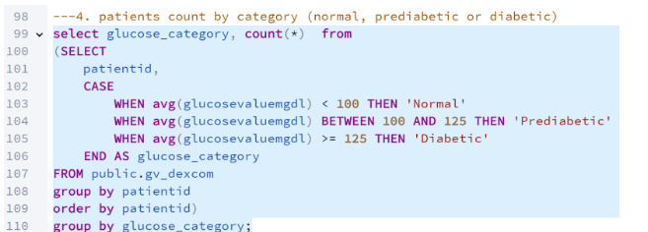

OUTPUT:

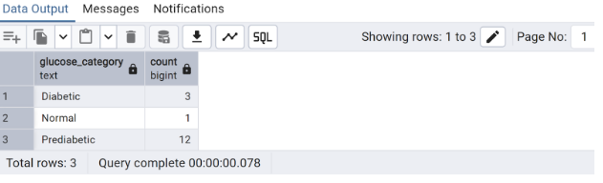
Insights: In the given dataset, the majority fall under Pre-Diabetics. Counts help in resource allocation

- Show total calorie intake of patients in a day
QUERY:
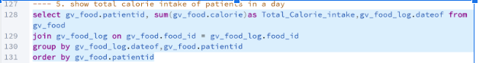
OUTPUT:
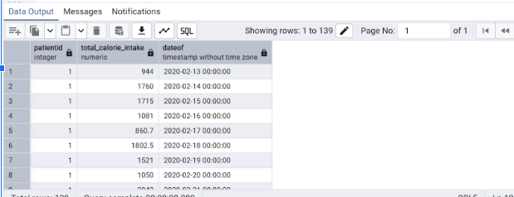
Insights : Understand which patients consume more or fewer calories and identify trends or outliers like unusually high or low intake days.

- Follow-up to the above Query: Compare calorie intake of patient per day with gender
QUERY:
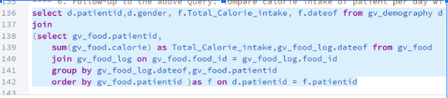
OUTPUT:

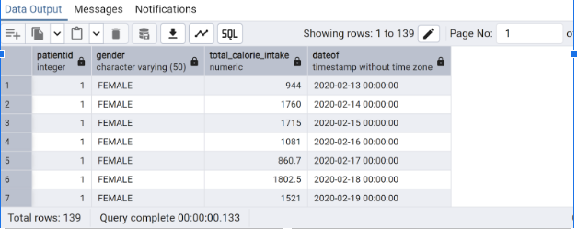

Insights: This query provides gender-based dietary analysis showing calorie intake
of each patient and helps in extending the analysis about glucose control, weight or
other health metrics.
- Average glucose within 3 hours after food logged?
QUERY:

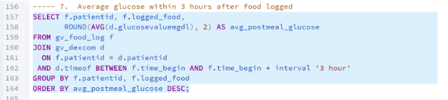
OUTPUT:

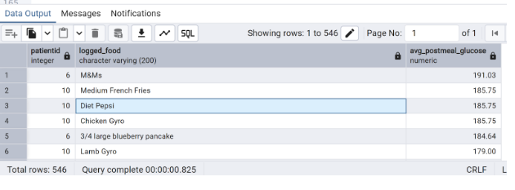
Insights: This query tells the average glucose reading of each patient 3 hrs
after food intake. In Prescriptive analysis, this is useful in dietary recommendations
for Diabetes management.

- List all the foods with their calories from highest to lowest?
QUERY:
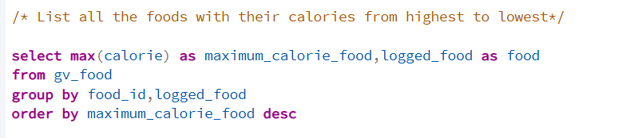
OUTPUT:
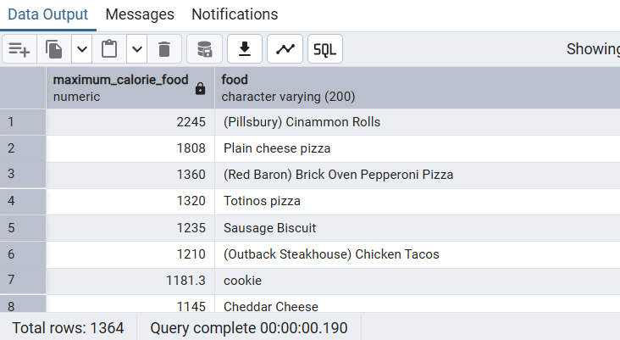

- Find the minimum hba1c value for each gender
QUERY:

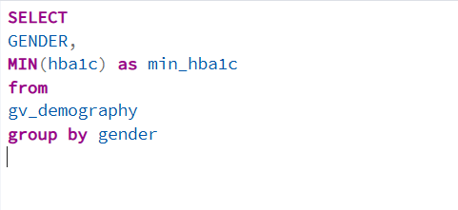

OUTPUT:

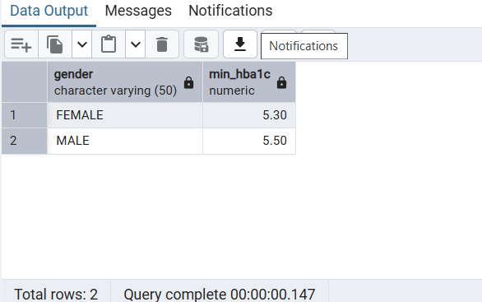

Insights: This query identifies the lowest HbA1c value for each gender, showing which group has patients with better blood sugar control. It helps highlight gender-based differences in minimum diabetes risk levels.

- List the food with the maximum calorific value?

QUERY:

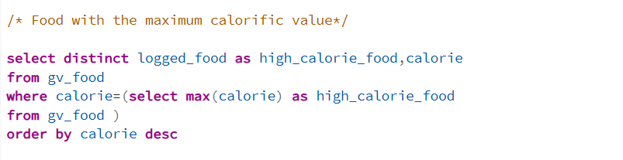

OUTPUT:

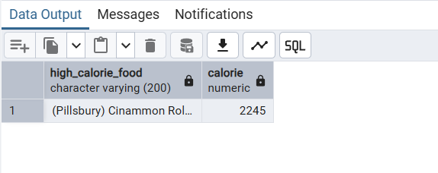

- List the foods which have maximum protein content

QUERY:
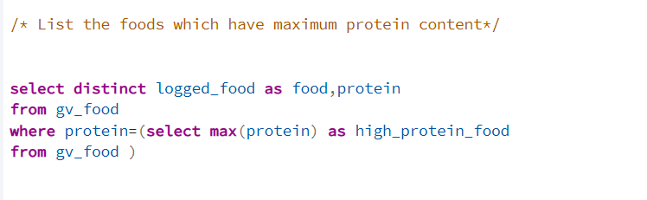

OUTPUT:

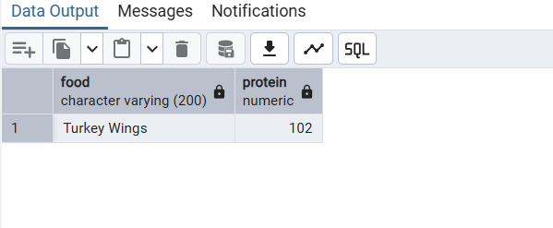
- List all the foods with their fiber content highest to lowest
QUERY:

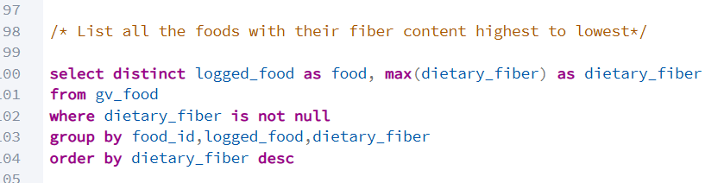

OUTPUT:
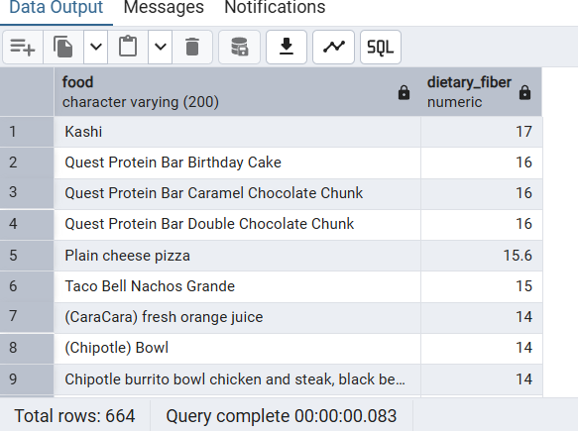

- List the foods which are high on fat?
QUERY:

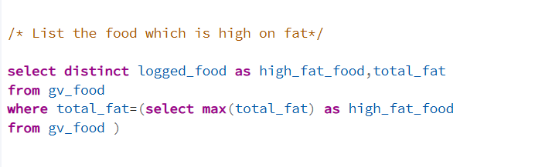

OUTPUT:

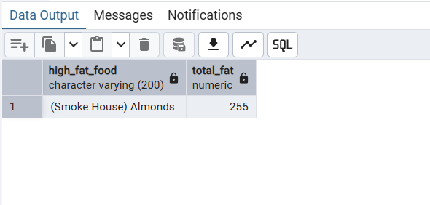

- Categorize patients based on their temperature levels?
QUERY:
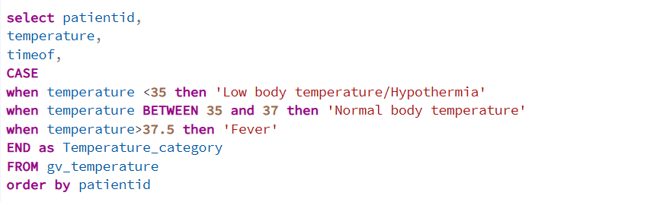

OUTPUT:
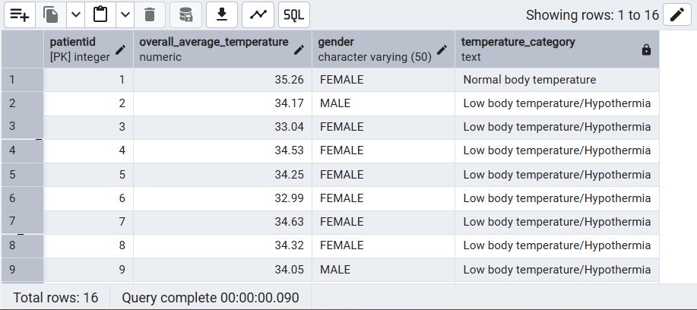

- Calculate the average heart rate per day for each patient
QUERY:
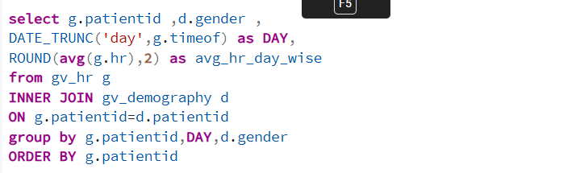

OUTPUT:

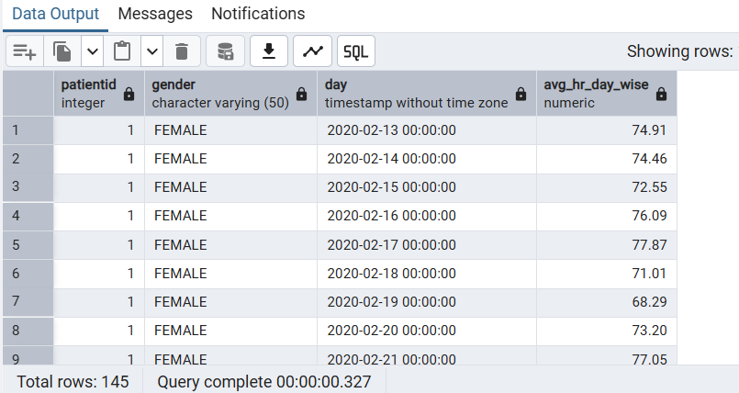

- To calculate day wise ibi values for all the patients
QUERY:
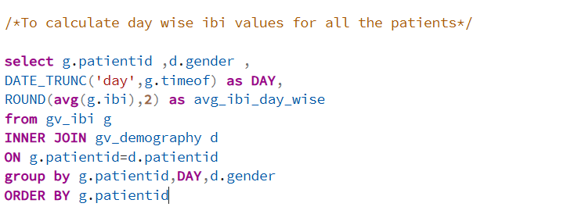
OUTPUT:
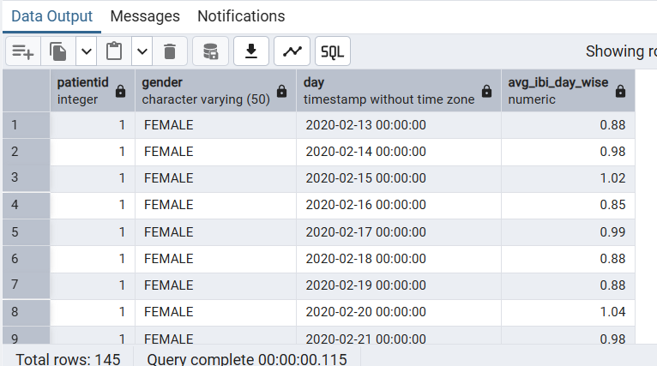

- Calculate the average heart rate per day for each patient.
QUERY:

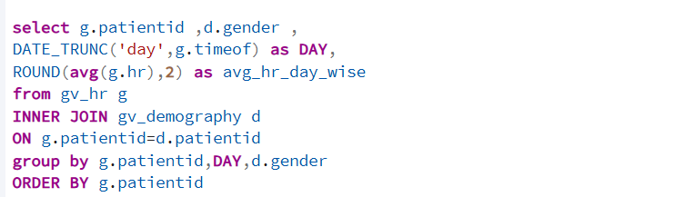
OUTPUT:

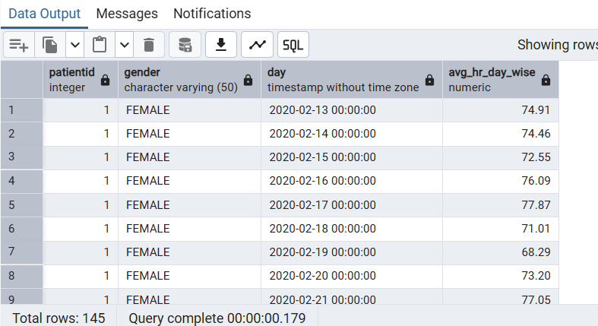

- Calculate the average EDA per day for each patient
QUERY:
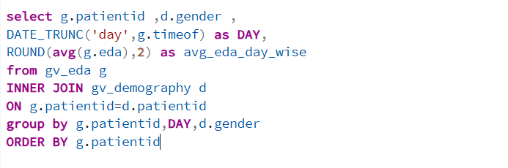
OUTPUT:
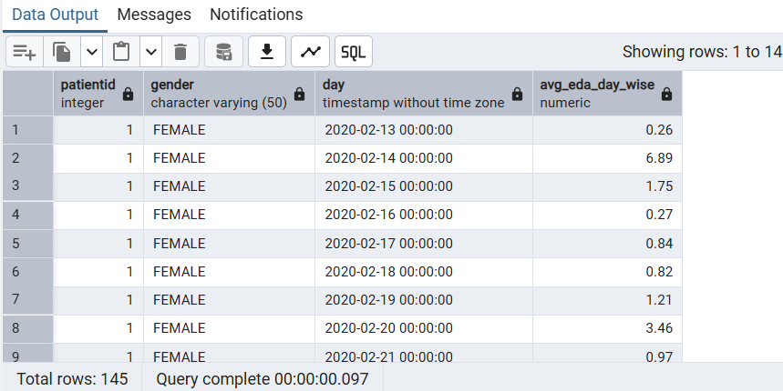

- Calculate the average temperature measured per day for each patient
QUERY:

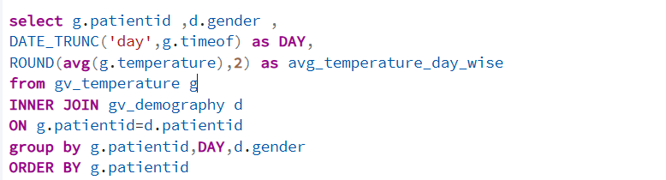

OUTPUT:

